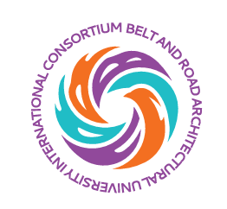
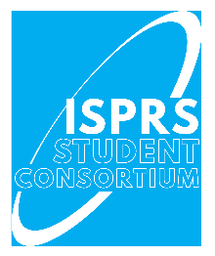



2026 Summer School on Smart Cities

July 10-18, 2026

APPLICATION FORM

Please complete this application form and send it to: buceaiss@hotmail.com no later than 1st June 2026. Applications received after this date WILL NOT be considered. The organizers will review the applications and send the notification of acceptance to those who meet the requirements.

Passport Name |  |  | Passport No.
Family Name |  |  | Given Name
Gender | Female Male |  | Nationality
Religion |  |  | Date of Birth (YYYY-MM-DD)
Place of Birth |  |  | City
Degree |  | Bachelor Master PhD
Major
English Level (CET/TOEFL/IELTS)
Organization (indicate the department of your university or agency)
Position
Contact address
Telephone Number
Mobile Number/ Wechat Number
Email Address

